1. What are Element Operators in LINQ?

In LINQ (Language Integrated Query), Element Operators are a group of standard query operators that allow you to retrieve specific elements from a collection based on certain conditions or criteria. These operators help you work with data more granularly by selecting individual elements or a single element that meets your requirements.

The Element Operators in LINQ are used to return a single element from a data source using the element index position or based on a predicate, i.e., based on a specified condition. These Element Operators can be used with a single data source or on a query of multiple data sources.

1. Why do we need to use the Element Operators in LINQ?

If you want to perform the following operations, you must use the Element Operators.

* Select the First record from a data source.
* Select the First record from a data source based on a given condition.
* Fetch a specific record from the data source.
* Fetch a specific record from the data source based on the given index.
* Select the last record from a data source.
* Select the last record from a data source based on a given condition.

1. General Guidelines for Using Element Operators in C#:

* Ensure the collection is not null to avoid NullReferenceException.
* Be aware of the default values (for the OrDefault methods) since they differ based on the data type (e.g., null for reference types, 0 for numeric types, false for bool, etc.).
* Understand the performance implications. For example, using Last or LastOrDefault on a large sequence might be costly if the sequence is not an IList<T> because the entire sequence must be iterated.
* Use SingleOrDefault and Single judiciously as they iterate the entire collection to ensure only one element exists, which could have performance implications.

1. What Methods are Available in the Element Operators Category?

In LINQ (Language-Integrated Query), element operators are used to retrieve specific elements from a sequence, such as an array or a list. These operators include methods like First, FirstOrDefault, Last, LastOrDefault, Single, SingleOrDefault, and ElementAt.LINQ provides the following methods to perform element operations.

1. First:

* Returns the first element of a sequence.
* It throws an exception if the sequence contains no elements.
* Use when: You need the first element of a collection, and you are sure that the collection is not empty.
* Example: Getting the first order from a list of orders for a customer.

1. FirstOrDefault:

* Returns the first element of a sequence or a default value if the sequence contains no elements.
* Useful when the sequence might be empty and you want to avoid an exception.
* Use when: You want the first element, but the collection might be empty, and you want to handle that case gracefully without throwing an exception.
* Example: Trying to fetch the first item in a shopping cart with no items.

1. Last

* Returns the last element of a sequence.
* It throws an exception if the sequence is empty.
* Use when: You need the last element of a collection, and you are certain the collection contains at least one element.
* Example: Selecting the most recent transaction from a list of transactions.

1. LastOrDefault

* Returns the last element of a sequence or a default value if the sequence is empty.
* Like FirstOrDefault, it avoids exceptions when the sequence is empty.
* Use when: You want the last element, but there’s a possibility the collection could be empty, and you need a default value to handle that scenario.
* Example: Getting the last logged event from an event log that might be empty.

1. SingleOrDefault

* Returns the single element of a sequence or a default value if the sequence is empty.
* It throws an exception if there is more than one element in the sequence.
* Use when: You expect the collection to have zero or one element and want to handle the case where the collection is empty without throwing an exception.
* Example: Looking up a configuration setting that may or may not be set.

1. ElementAt

* Returns the element at a specified index in a sequence.
* It throws an exception if the index is out of range.
* Use when: You need an element at a specific position in the collection, and you are sure that the element exists at that position.
* Example: Selecting a specific seat from a list of seats on a flight.

1. ElementAtOrDefault

* Returns the element at a specified index in a sequence or a default value if the index is out of range.
* Use when: You want an element at a certain position, but the collection might not have an element at that index, and you need a default value to handle that case.
* Example: Attempting to retrieve the fifth item from a list containing fewer than five items.

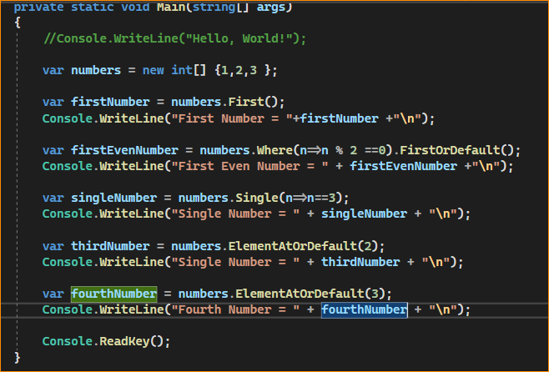

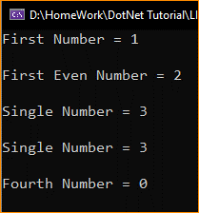

When using these operators, it’s important to consider the characteristics of the data source and what you expect from it—whether it’s guaranteed to have elements, whether it could have multiple elements, and so forth—to choose the most appropriate operator and avoid runtime exceptions.

1. When to use Element Operators in LINQ?

Element operators in LINQ are used to retrieve specific elements from a collection based on certain conditions or criteria. You should consider using element operators when you have the following requirements:

**Retrieving Specific Elements:** If you need to fetch specific elements from a collection that match a particular condition, element operators are useful. For example, you want to find the first product with a specific name in a list of products.

var product = productList.First(p => p.Name == “ProductA”);

**Handling Missing Data:** Element operators like FirstOrDefault, LastOrDefault, and ElementAtOrDefault are helpful when you want to avoid exceptions (e.g., InvalidOperationException) in case the element you’re looking for might not exist in the collection. When no matching element is found, these operators return a default value (usually null for reference types).

var product = productList.FirstOrDefault(p => p.Id == 123);

**Getting the First or Last Element:** When you need to retrieve the first or last element of a sequence that meets certain conditions, the First, Last, Single, and their corresponding OrDefault variants are suitable. For example, you might want the last item in a sorted list.

var lastItem = sortedList.Last();

**Accessing Elements by Index:** When you need to access elements in a sequence by their index position (e.g., to retrieve the 10th item), you can use the ElementAt or ElementAtOrDefault operators.

var tenthItem = myList.ElementAt(9);

**Enforcing Specific Cardinality:** Use the Single or SingleOrDefault operators when you expect exactly one matching element in the collection and want to enforce this constraint. These operators throw exceptions if there are multiple matches or none at all.

var uniqueItem = myList.Single(item => item.IsUnique);

**Optimizing Query Performance:** In some cases, you might want to optimize the performance of your queries by stopping as soon as you find the first matching element. The First, FirstOrDefault, Single, and SingleOrDefault operators can be more efficient than retrieving all matching elements and filtering them.

Remember to choose the appropriate element operator based on your specific requirements and the nature of your data source. Additionally, consider handling exceptions or missing data gracefully to ensure the stability and reliability of your application.